**Unit 1 Assignment - KickStart My Chart Report**

Over two billion dollars have been raised using the massively successful crowdfunding service, Kickstarter, but not every project has found success. Of the over 300,000 projects launched on Kickstarter, only a third have made it through the funding process with a positive outcome.

Since getting funded on Kickstarter requires meeting or exceeding the project's initial goal, many organizations spend months looking through past projects in an attempt to discover some trick to finding success. A limited analysis of a sample of Kickstarter projects reveals some insight into finding funding success through Kickstarter.

**Conclusions**

A first conclusion we can draw is that projects related to the arts (i.e. Theater, Music, and Film & Video) have reached or exceeded funding goals significantly more often than other category types [Chart 1]. Within the Theater category, funding for Plays was sought and funded significantly more often than other subcategory projects [Chart 2]; in the Music subcategory, Rock and Indie Rock projects accounted for the most requests and successful funding campaigns [Chart 3]; and similarly, Documentaries accounted for the most requests and funded projects in the Movie subcategory [Chart 4].

|  |  |
| --- | --- |
| Chart 1 | Chart 2 |
|  |  |

|  |  |
| --- | --- |
| Chart 3 | Chart 4 |
|  |  |

A second conclusion we can draw from the limited data is that projects requesting less than $10,000 have a success rate of more than 50 percent [Chart 5]. While the data shows that funding success for projects up to $10,000 is 53 percent, it also shows that requests for less than $10,000 are even more likely to be funded, with requests in the $1,000 to $5,000 range being successful 66 percent of the time and requests of up to $1,000 at 70 percent.

Chart 5

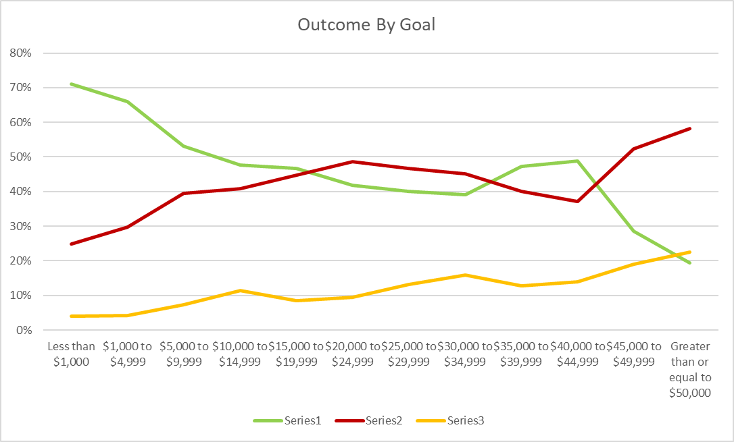

A third conclusion that can be drawn from the data is that significantly more projects are successful than fail when the funding request is made from February through June [Chart 6]. While the data shows that in all months, excluding December, there seems to be a significant difference between success and failure during the months of February through June. The data also shows another significant difference between success and failure for projects launched in November.

Chart 6

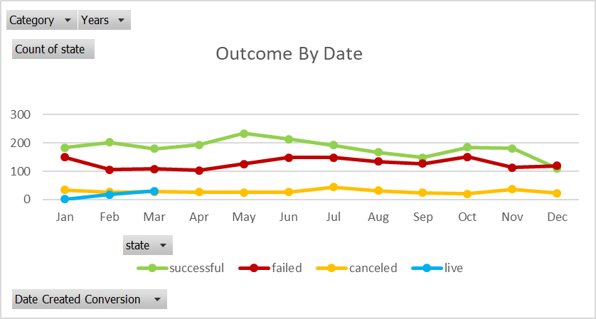

**Limitations of this dataset**

The most significant limitation of this data set is that it is a sample of 4,000 request from an estimated population of more than 300,000 requests made through Kickstarter. Depending on how this sample was drawn from the population, sampling errors could exist that may not allow a generalization of the findings. An analysis of the entire population of Kickstarter campaigns would address this.

The dataset also does not include any data about outside influences (i.e. relatedness to current news topics, level of publicity) that could have influenced the success, failure, or cancellation of funding requests. Understanding the external environment could significantly increase the understanding of why a request was successful of not.

**Other possible tables/graphs**

The following list of tables/graphs would be helpful in uncovering additional insights.

* Outcome by category and subcategory by year – This would provide insight into outcomes over time which would make it easier to spot overall trends. By adding “by Country” to this chart would allow you to see trends at the country level.
* Outcome by Goal by Year by Country – This would be helpful to spot trends in funding (i.e. which countries are funding requests at higher levels). This could help determine which country a request is launched from and targeted to.
* Outcome (Successful) by # Backers by Goal – This would be helpful in estimating how many Backers are needed to succeed at various Goal levels.
* # Backers by Outcome (Successful) by Category/Subcategory – this would be helpful in determining how many Backers may be needed for requests in different Categories/Subcategories.
* Avg Donation by Country by Category/Subcategory by Year by Outcome (Successful) – This would help spot funding trends by geographical location.